K.P.C. PUBLIC SCHOOL, KHARGHAR
Assessment I 2022-2023

GRADE: VII MARKS: 40
SUB: MATHS TIME: 2 HRS
Q1: CHOOSE THE CORRECT OPTIONS: 6 M
- Sum of an integer and its additive inverse is always _________.
- Positive b. 0 c. Negative
- Complete the sequence -8000, -4000, ______, 4000, _____.
- 2000,1000 b. -3000,3000 c. 0, 8000
- Reciprocal of 10 is ____.
- $\frac{1}{10}$ b. 10 c. 0
- An equilateral triangle has ____ lines of symmetry.
- Three b. Five c. Two
- The order of rotation of a circle is _____.
- 5 b. 1 c. Infinite
- 0.01 x 0.00001= ______.
- 0.1 b. 0.001 c. 0.0000001
Q2: SOLVE THE FOLLOWING 5 M
- Multiply (-10) x 5 x (-3)
- Write the expanded form of 2.5081
- Write the expanded form 50+8+0.2+0.005 as decimal number
- Find the product of 2.053 x 1000
- Draw a quadrilateral which has two lines of symmetry.

Q3: SOLVE THE FOLLOWING ACTIVITY 6 M
- Vaibhav is an enthusiastic sport boy while practicing long jump he manage 90cm on the first day, second day onwards he manages to jump 2 cm longer than the previous day and so on. On the sixth day how long did he jump?
Solution: -
On first day Vaibhav jumped 90cm
Second day _____ = ____ cm
Third day 92+2=94 cm
Fourth day ______ = _____cm
Fifth day 96+2=98cm
Sixth day _______ = _____ cm
Vaibhav jumped _____ cm long on sixth day

- Divide $\frac{2}{3}$ ÷ $\frac{10}{9}$
Solution: $\frac{2}{3}$ ÷ $\frac{10}{9}$
= $\frac{2}{3}$ x reciprocal of
= $\frac{2}{3}$x = $\frac{18}{}=\frac{}{}$

- Complete the following figures by drawing a symmetrical figure on the other side of the line of symmetry.

Q4. EVALUATE THE FOLLOWING: [Any 4] 8 M
- Simplify the following:
- (8.21+5) – 13.5
- 43.086 + 15.792
- The product of two number is $\frac{5}{6}$. If one of the numbers is $\frac{7}{2}$, find the other number.
- Find the weight of 230 marbles if each marble weighs $10\frac{1}{2}$ grams.
- Find 2 x (-5) using the number line.
- Divide 17.628 by 1.3

Q5. EVALUATE THE FOLLOWING: [Any 3] 9 M
- [ -437 – 1 + 8] + [234 – (-10)] – [15 + (-17)]
- Find the area of square park with side $15\frac{1}{5}m$.
- Write the centre of rotation, direction of rotation and order of rotation for the following figure.
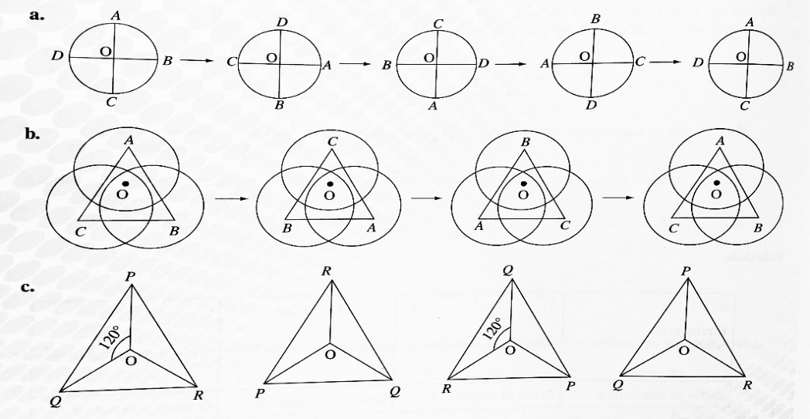
- [ $2\frac{1}{7} x 1\frac{3}{46} ] ÷[ \frac{18}{23} x\frac{5}{7} ]$

- (-2) x (-3) x (-4) x (-5) x (-6)

Q6. SOLVE THE FOLLOWING [Any 2] 6 M
- A fan rotates at the speed of 123.5 rotation per minute. If the speed of a regulator is adjusted to increase the speed of a fan 3.5 times, find the number of rotations per minute of the fan.
- Vineet’s mother gave him ₹ 200. He brought a book of ₹ 158.50, a pen for ₹ 15.50 and a paper folder of ₹ 20.50. how much money did he gave to the shopkeeper? How much money is left with him?
- Varsha bought 7kg 10g rice and 1 kg 500g wheat. Rita bought 5 kg 400g rice and 3 kg 600g wheat. Find which one of them bought more rice and wheat together?
- The weight of the box is $7\frac{2}{3}$ kg. How many boxes can be shipped if a boat can carry a weight of 690kgs?

